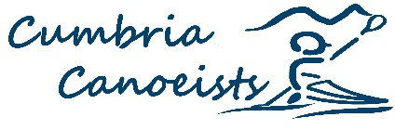
Stand up Paddle Boarding Reps Report 2022

No approach from Clubs for help with Sup needs.

Sessions organised: a lady’s session day with SHEpaddle Ambassador Charlotte but had to cancel due to lack of numbers.

Supported Killington Sailing Association with SUP sessions over the summer.

SUP is such a complex paddlesport problem at the moment with everything that is going on with qualifications, governing bodies and the way that participants and the general public see paddleboarding, it's not clear where to go with it.

Anthony – Border kayaks & Canoes

